**SRS Documentation**

**Bus Management**

**(Assignment 2)**

Prepared by

**DEBOPRIYO GHOSH**

**SAIKAT JANA,**

**MOUSUMI MONDAL,**

**SARADINDU RANA,**

**B.Tech., Sem - V, Group - 1**

Dated: 20 /01/2021

Contents

* 1. **Assignment 1**

1. Data Requirement
2. Assumptions
3. Entity - Relationship Diagram
4. Relationships
5. Relational Schema
6. Normalization of Relational Schema

**Assignment**

**Two case studies are given below. You have to analyse the situation; prepare the requirements (functionalities i.e. the probable reports that may be needed by consumers); accordingly decide the data requirement, express it through E-R data model. clearly state the assumptions, if any.**

**Case Study 1**

**A Country Bus Company owns a number of busses. Each bus is allocated to a particular route, although some routes may have several busses. Each route passes through a number of towns. One or more drivers are allocated to each stage of a route, which corresponds to a journey through some or all of the towns on a route. Some of the towns have a garage where busses are kept and each of the busses are identified by the registration number and can carry different numbers of passengers, since the vehicles vary in size and can be single or double-decked. Each route is identified by a route number and information is available on the average number of passengers carried per day for each route. Drivers have an employee number, name, address, and sometimes a telephone number.**

1. **Data Requirement**

**TOWNS**: Each town has unique Town name and the State in which the town issituated. Also Area covered by this town.

**BUSSES**: Every bus has unique Registration number which is given by the country.

**TYPE**: It describes the type of the bus. Every type of bus has an individual id whichdecide its size, deck number and number of passengers can travel in it. Size can be differentiating in large, medium and small. Deck may be single or double.

**ROUTES**: Every route has specific Route number, Average passenger i.e. number ofpassenger travel per day on this route.

**DRIVERS**: Each driver has unique employee id, name of driver, Address andTelephone number.

**GARAGE**: Every garage is situated in a particular town. Every garage has uniquegarage id given by country, Capacity which denote maximum number of buses can be kept in the garage.

**STAGES**: Stage is the part of along route. Each stage has specific stage id to identifystage of a route.

1. **Assumption**
2. This is a simple Bus management system where every procedure is not same as the real-life management systems, here we can develop many functionalities according to our needs. Hence we are avoiding many complex situations which may occur in proper Bus management system. The system may have modified to generate a more improved version.

* 1. This Bus management system may contain one or many an administrator whose role is to organize the database and they are not a direct part of the database.
  2. Whenever the User wants to find the route between two different bus stops he/she gives input to the system the source and destination bus stop. Now after receiving the input the system checks whether any route exist between the stop or not and displays the result accordingly. Multiple routs can originate from one bus stop. It is not necessary that there exists a route between two stops.
  3. The system keeps track of the total buses and drivers and corresponding routes, hence it also knows the number of available buses in respect to each garage and each route. Now the booking ticket of the available buses is not a part of the database. And allocation of drivers and garages, changes of routes by admin can be modified with this system later on.

1. **Entity Relationship Diagram A. Diagram**

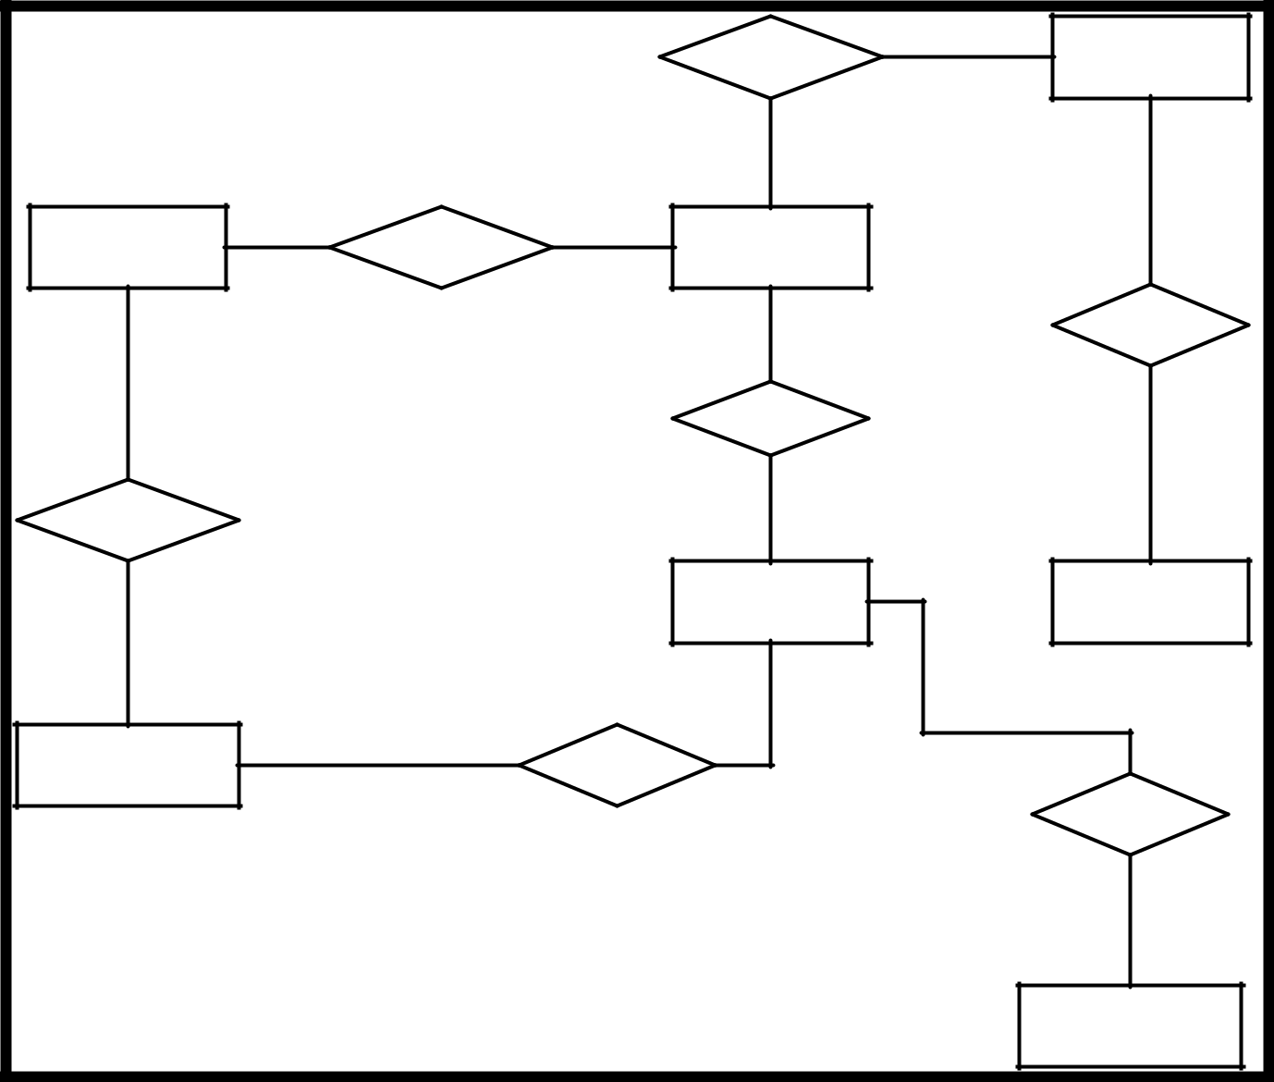

|  |  |  |  |  |  |
| --- | --- | --- | --- | --- | --- |
|  |  | **HAVE** | (1,N) | **STAGES** |  |
|  |  |  |  |
|  |  | (1,1) |  | (1,M) |  |
|  |  |  |  |  |
| **TOWNS** | (1,N) | (1,M) |  |  |  |
| **PASS** | **ROUTES** |  |  |  |
|  |  | (1,1) |  | **DRIVE** |  |
| (1,1) |  |  |  |  |  |
|  |  | **ALLOCATE** |  |  |  |
|  |  | (1,N) |  | (1,N) |  |
| **HAVE** |  |  |  |  |
|  |  |  |  |  |
| (0,1) |  | **BUSSES** |  | **DRIVERS** |  |
|  |  |  |  |  |
|  |  | (1,N) |  |  |  |
| **GARAGE** | (1,1) | **KEEPS** | (0,N) |  |  |
|  |  |  |
|  |  |  |  | **HAVE** |  |
|  |  |  |  | (1,1) |  |
|  |  |  |  | **TYPE** |  |

1. **Description**
   1. In this diagram there are no weak entities.
   2. The entities are Bus, Town, Route, Stage, Garage, Driver, Type.
   3. There are many type of Busses. So, “Busses” and “Type” are connected through a relationship.
   4. Busses are passed through a particular route. And Busses are kept in a particular

Garage. So, “Busses” are also connected through relationship with “Route” and “Garage”.

* 1. Some of the Towns have Garages. so, “Town” and “Garage” are connected through a relationship.
  2. A town has many Number of route, and also a route covers one or more town. So,

“Town” and “Route” are connected through a many to many relationships.

* 1. Now, routes also have one or more stage. So, “Route” and “Stage” are connected through a relationship.
  2. A driver drives the bus through many number of stage, and also in a particular stage many drivers drives their busses. So, “Driver” and “Stage” are connected through a many to many relationships.

1. **Attribute**

TOWNS: { Town_name , State, Area }

BUSSES: { Reg_no }

TYPE: { Type_id , Size , Deck , Passenger_no }

ROUTES: { Route_no , Avg_passenger }

DRIVERS: { E_id , E_name , Address , Tel_no }

GARAGE: { G_id , Capacity}

STAGES: { S_id }

1. **Relationships**
   1. A bus is allocated to a route and a route may have several busses.
   2. Bus-route (N:1) is serviced by
   3. A route comprises of one or more stages.
   4. Route-stage (1:N) comprises
   5. One or more drivers are allocated to each stage and one driver may drive one or more stages.
   6. Driver-stage (N:M) is allocated
   7. A route passes through some or all of the towns.
   8. Route-town (M:N) passes-through
   9. Some of the towns have a garage.
   10. Garage-town (1:1) is situated
   11. A garage keeps buses and each bus has one `home' garage.
   12. Garage-bus (1:N) is garaged
   13. Each bus has a specific type.
   14. Bus-type(N:1) specified

**5. Relational Schema**

|  |  |  |  |
| --- | --- | --- | --- |
| **TOWNS** |  |  |  |
| **Town_Name** | **State** | **Area** |  |
| **BUSSES** |  |  |  |
| **Reg_No** | **Route_No** | **GId** | **Type_Id** |
| **TYPE** |  |  |  |
| **Type_Id** | **Size** | **Deck** | **Passenger** |
| **ROUTES** |  |  |  |
| **Route_No** | **Avg_Passenger** |  |  |
| **DRIVERS** |  |  |  |
| **EId** | **EName** | **Address** | **Phone** |
| **GARAGE** |  |  |  |
| **GId** | **Town_name** | **Capacity** |  |
| **STAGES** |  |  |  |
| **S_Id** | **Route_No** |  |  |
| **DRIVE** |  |  |  |
| **Route_No** | **S_Id** |  |  |
| **PASS** |  |  |  |
| **Town_name** | **Route_No** |  |  |

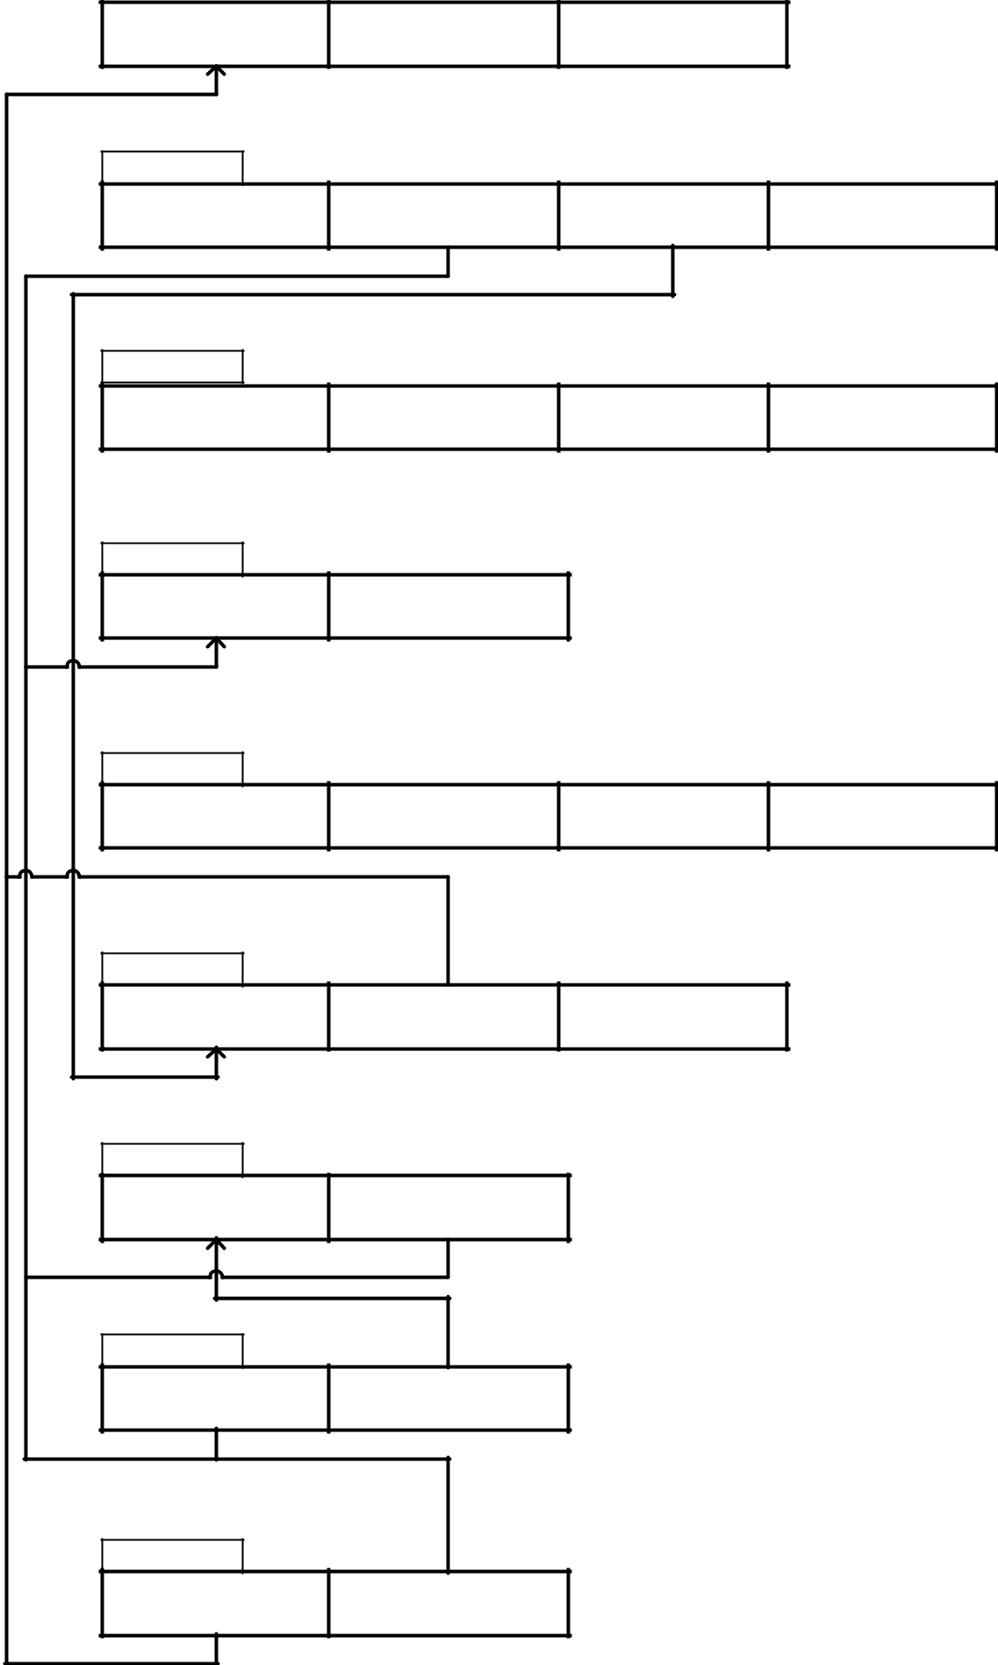

1. **Normalization of Relational Schema**
   1. **TOWNS table has {Town_name ,State , Area } attributes.** Town_name is primary key .

Town_name -> {State, Area} So , table TOWNS is in 3NF .

* 1. **BUSSES table has { Reg_no , G-id ,Type_id, Route_no} attributes.** Reg_no is the primary key.

G_id ,Type_id, Route_no are the forgien key related to the GARAGE,TYPE and ROUTE table

Reg_no ->{ G-id ,Type_id, Route_no}

There are no other functional dependency so BUSSES table in 3NF.

* 1. **TYPE table has {Type_id, Size, Deck, Passenger_no}** Type_id ->{ Size, Deck, Passenger_no}

Type_id is primary key. So the table is in 3NF.

* 1. **ROUTES table has {Route_no, Avg_passenger} attributes.** Route_no is primary key .

Route_no -> {Avg_passenger} So , table TOWNS is in 3NF .

* 1. **DRIVERS table has {E_id, E_name, Address, Tel_no}** E_id-> {E_name, Address, Tel_no}

E_id is primary key. So the table is in 3NF.

* 1. **GARAGE table has {G_id, Town_name, Capacity}**

Town_name is the forgien key related to the table TOWNS. G_id -> { Town_name, Capacity}

G_id is the only primary key. So the table is in 3NF.

* 1. **STAGES table has {S_id, Route_no}**

Route_no is the forgien key related to the table ROUTES. S_id -> { Route_no}

So the table is in 3NF.

* 1. **DRIVE table has {E_id, S_id}**

DRIVE table is created to relate DRIVERS and STAGES table. So the table is in 3NF.

1. **PASS table has {Town_name,Route_no}**

PASS table is created to relate TOWNS and ROUTES table. So the table is in 3NF.